SPDC WRFM – Process Optimization

|  |  |
| --- | --- |
|  |  |
| Title | Soku Flow Station Fuel Gas Buy Back from Soku Gas Plant Note to File |
| Document Number | SPDC-2022-07-00000027 |
| Author(s) | Nmamkoche Offurum |
| Reviewed/Approved by | Barka Chiroma |
| Publish Date | July 2022 |
|  |  |
|  |  |
|  |  |
|  |  |

Soku Flowstation Fuel Gas Buy Back from Soku Gas Plant Note to File

**Revision History**

|  |  |  |  |  |  |
| --- | --- | --- | --- | --- | --- |
| **REVISION STATUS** | | | **SIGNATORIES** | | |
| **Rev.** | **Date** | **Description** | **Originator** | **Reviewer** | **Approver** |
| R01 | 07/02/2022 | Issued for Review |  |  |  |
| R02 | 07/27/2022 | Issued for Review |  |  |  |
|  |  |  |  |  |  |
|  |  |  |  |  |  |
| * Preliminary issue will be issued as P01 * Revisions for review will be issued as R01, with subsequent come as R02 etc. * Revisions approved for Implementation/Design Issue/Eng. will be issued as A01, with subsequent come as A02 etc. * Revisions approved for Tender will be issued as T01, with subsequent come as T02 etc. * Revisions approved for Construction (AFC)/Purchase will be issued as C01; with subsequent comes as C02 etc. * Highlights of sections revised from previous approved issues or reasons for version change are to be listed in the description box * All revisions to this document must be signed by the relevant Technical Authority (TA1, TA2 or TA3) | | | | | |

**Signatures for this revision**

|  |  |  |
| --- | --- | --- |
| **Role** | **Name** | **Signature/Date** |
| **Originator** | Nmamkoche Offurum |  |
| **Reviewer/Approver** | Barka Chiroma |  |

More field(s) could be added for signature if additional agreement/approval is required.

# **Background**

The Process Optimization WRFM team carried out a feasibility study to assess the possibility of buying back gas from Soku Gas plant to the flow station using existing facilities. In the course of the work, the feasibility of the proposed options was assessed, and the assessment findings and recommendations are detailed out in this report.

Soku flow station is designed to run-on gas-powered generator and black start diesel generator. However, due to frequent NCTL outage that results in a loss of fuel gas, diesel generator is used to maintain power supply to preserve process control systems and instrumentations.

This impacts on OPEX cost and potential for environmental impact. To drive continuous improvement in our business processes, the initiative to explore gas buy-back from Soku Gas Plant to Soku Flowstation to run the gas generator in the event of NCTL outage to avert running the station on diesel generator and eliminating the cost on diesel consumption was conceived.

Three possible gas sources in Soku Gas plant were proposed by the production operations team:

**Option I: Fuel gas buy back to Soku Flow station from Soku gas plant HP AG Slug catcher via existing eighteen (18) inch Soku Flow Station HP AG export line.**

This option aims to reverse AG flow from Soku gas plant to Soku flow station through the HP AG slug catcher V1102A/B, the AG will come from 3rd party AG export facility.

To successfully use the existing line, extensive work will be required to identify all safeguards and blowdown valves (as well as the export line shutdown valve 11-UZV-303); the valves will need to be automatically re-opened or closed (during reverse flow operations) and reversed to their failure state when switching to Normal mode of operation.

This will require the use of a hardwired mode selector switch to the SIS system for “Reverse” Mode (Soku GP flow via HP export line) and “Normal” (normal Soku flow station operations) mode selection. Selection of either mode shall automatically close or open all appropriate shutdown and blowdown valves according to a new revised Cause and Effects Chart.

**Pros**

1. Use of existing facility
2. Minor modification work required
3. Schedule

**Cons**

1. 3rd party reconciliation and allocation
2. Minor modification to reverse flow through/bypass check valves
3. Process automation/control modification - Reversal of all shutdown and blowdown valves to open position at Soku Flow station
4. Potential high cost for PACO modification
5. Dependence on third party for fuel gas supply

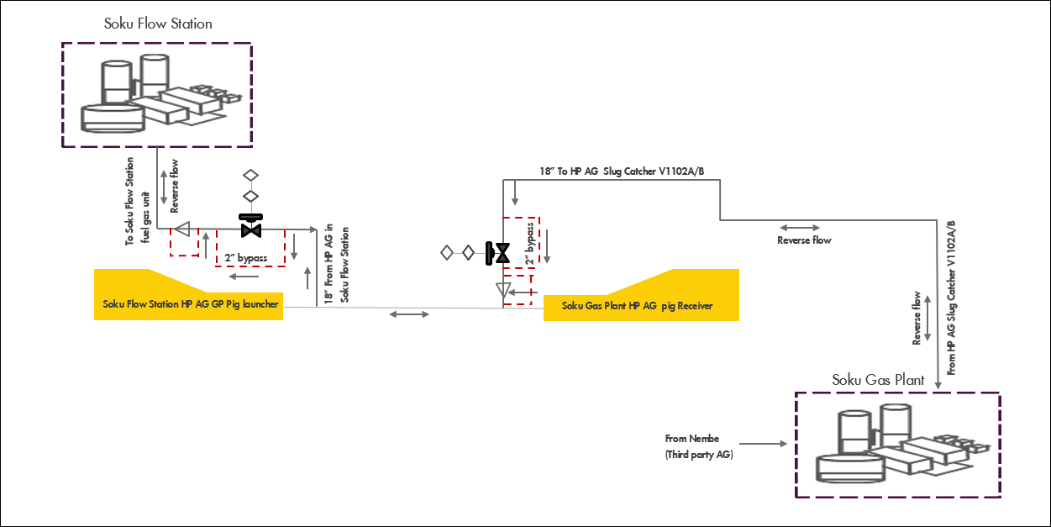

Fig 1. Process schematic option I- Using existing facility to reverse gas flow

**Option II:** **Hook up and rerouting of Fuel Gas from existing XHP flash gas header to AG compressor suction header.**

This option aims to tap-off from the 10-inch XHP AG/Flash gas line flowing to the AG/Flash gas compression suction header. A 2-inch by 300m line will be laid to take AG from the tap off point at Soku flow station to Soku gas plant fuel gas unit. Boundary shutdown valves will be installed to completely isolate the line when not in use or in the event of a safety incident. The need to install a meter to measure the amount of gas taken from Soku gas plant will be assessed.

The failure position of all safeguards and blowdown valves in Soku flow station fuel gas unit will be assessed to determine their mode of operation when gas is bought back from Soku gas plant.

**Pros**

1. Minor modification work required
2. Schedule

**Cons**

1. Process automation/control modification - Reversal of all shutdown and blowdown valves to open position at Soku flow station
2. Potential high cost for modification
3. Constructability/Do ability (ease of installation space availability in piping rack and RoW)
4. High source pressure control

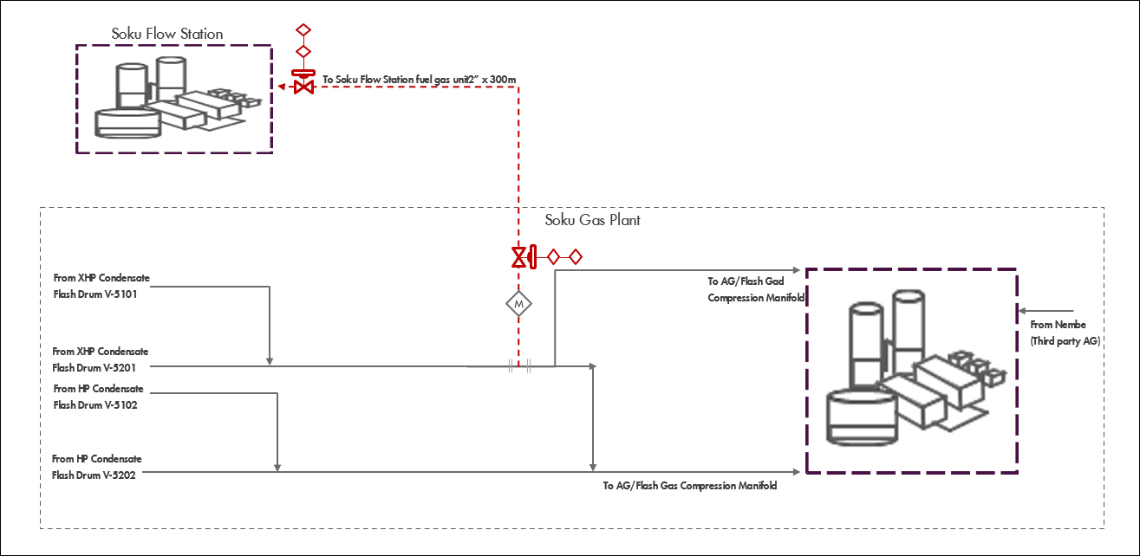

Fig 2. Process schematic option II- Gas buy back from existing XHP flash gas header

**Option III: Hook up and rerouting of fuel gas from existing Belema fuel gas buy back line to Soku flow station fuel gas unit.**

This option aims to tap off from the 4 inches fuel gas import line from Belema gas plant to Belema XXHP gas pig receiver. A 2 inch by 50m line will be laid to take AG from the tap off point at Soku flow station. A boundary valve and pressure control valve will be installed to mange the pressure from Soku gas plant. Due to the high source pressure, the line should have adequate safeguard or rating to manage the maximum envisaged pressure.

**Pros**

1. Minor modification work required
2. Schedule

**Cons**

1. Process automation/control modification - Reversal of all shutdown and blowdown valves to open position at Soku flow station
2. Constructability/Do ability (ease of installation space availability in piping rack and RoW)
3. High source pressure control concern
4. Unavailability of Belema flow station due to NCTL outage

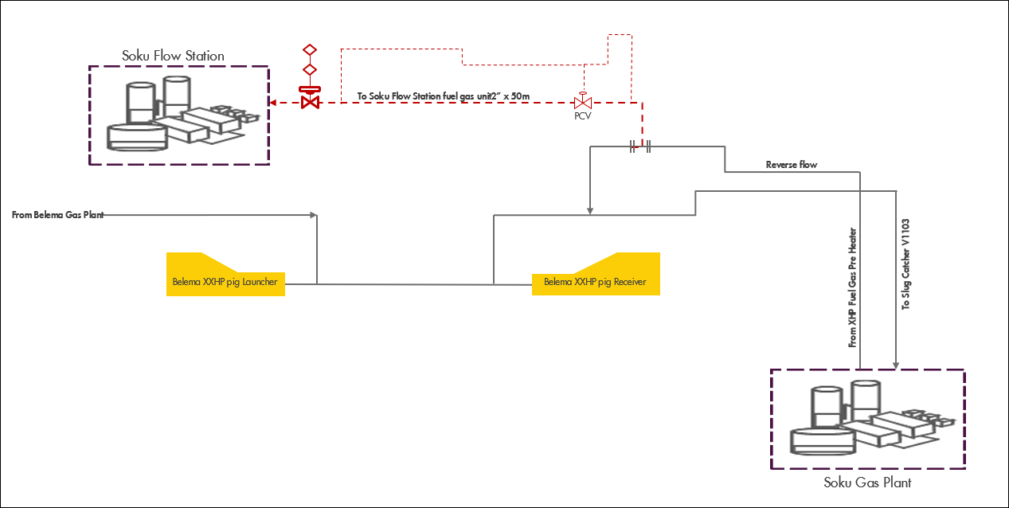Fig 3. Process schematic option III- Gas buy back from existing Belema fuel gas buy back line

# **Conclusion/Recommendation**

Based on the complexity of the proposed options, it was agreed to pause the project with opportunity to revisit it in the future. To ensure ease of execution in the future

1. A Process automation and control engineer will need to be involved from the start of the work activity
2. The non-return valves identified should be by-passed when fuel gas is imported from Soku gas plant or the internal of the non-return valve removed (to allow reverse gas flow from Soku gas plant to the flow station). However, during normal operation Soku gas plant operates at a higher pressure than the flow station the risk of backflow to the flow station will have to be extensively assessed.
3. Detailed scoping of the selected option (for design and execution).
4. The project will require a detailed cost estimation of the selected option to move forward.